Vertical line test to check whether a graph is a function or not

To use the vertical line test, take a ruler and draw a line parallel to the y-axis for any chosen value of x in domain. If the vertical line you drew intersects the graph just once for any value of x then the graph is the graph of a function.
If the line you drew intersects the graph more than once for some value of x then the graph is not the graph of a function (as that element in the domain will have 2 images).
If the line does not intersect the graph for some x in domain then the graph is not the graph of a function (as that element in the domain will not have any image).

Check whether these graphs are functions or not.

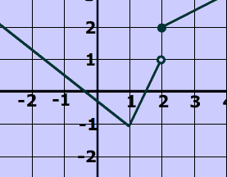

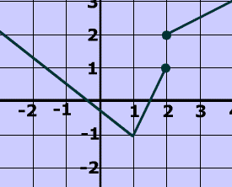

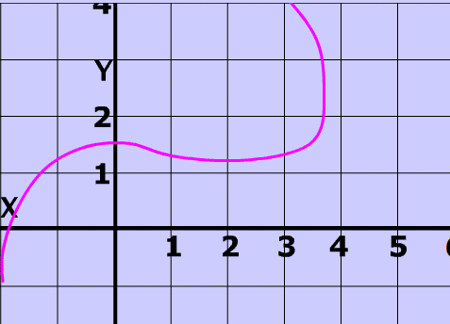

Horizontal line test for checking a function to be one-to-one

If a horizontal line intersects a function’s graph more than once, then the function is not one-to-one.

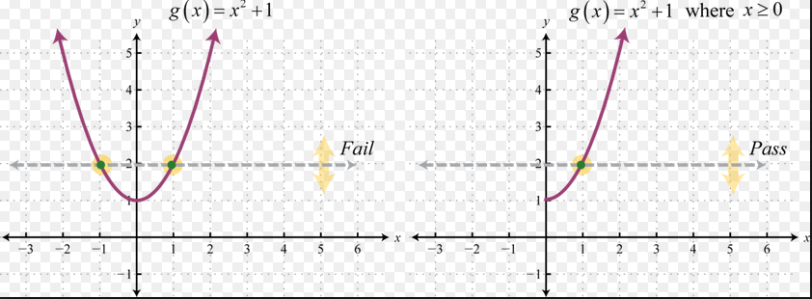

Line test for checking a function to be onto

If we can find a horizontal line passing through the co-domain that does not intersect the function’s graph, then the function is not onto.

Example: Let f: R→R given by f(x) = x²
We can find a line say, y=2 that does not intersect the graph of the function i.e. there does not exist any pre-image for y = 2 in co-domain R.

